Week 8 – Creating Tilesets

# Introduction

Throughout this lab, we are going to be looking at a free online editor for animated sprites and pixel art called, Piskel. This allows you to create assets online adding frames effectively, drawing your sprites and save your assets as either individual files (with each frame) or as an entire spritesheet/ tileset file.

We will look at creating different game environment/ elements for your game. You can put this as a test project or as an opportunity to start developing the appropriate assets for your Assessment 2 game that you will be working on throughout the coming weeks.

# Piskel

Piskel is an online tool to help create spritesheets which can also be used as a tileset (<https://www.piskelapp.com/>). Piskel as a GUI can allow you to add frames, draw your sprites and save each frame as individual files or as a spritesheet/ tileset file.

# Task 1: Start Creating Assets

Using Piskel, create different elements/ assets for your game environment and export as a spritesheet. This could be a character or an environment block, even a simple line for testing purposes now. The decision is all yours.

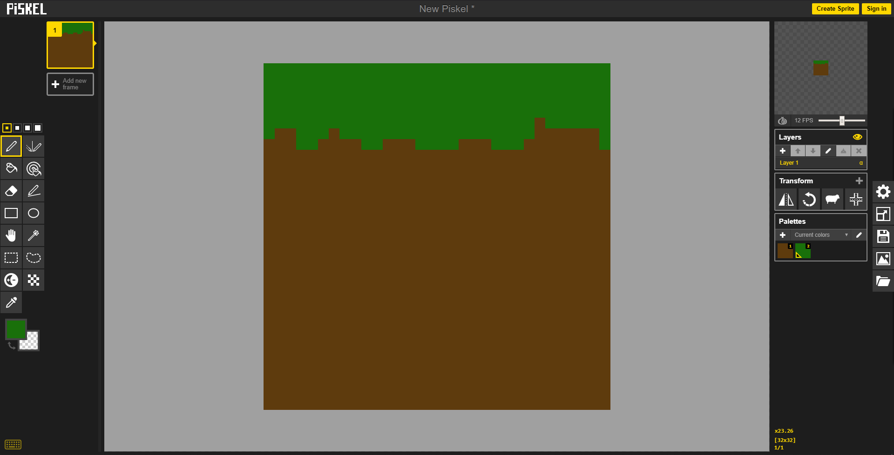

Once you have done this, on the computers within the lab, the Tiled (<https://www.mapeditor.org/>) software should be available. Tiled is a free software to help you create levels. It has tile editing tools allowing you to further export these into the appropriate formats to use for your game. If you wish to download this for using at home, use the link above and download on the website where appropriate.

# Task 2: Use Tiled to Create a Game Environment

Now using Tiled, we are going to look at creating and designing our game environment. First, when loading up Tiled, you will be asked what you wish to do first. You want to begin by creating a New Map. For the time being, you can keep the all settings as default.

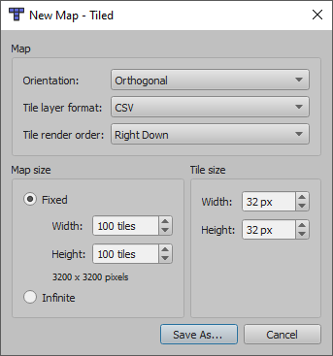

Once you have done this, press Save As... and save where necessary.

* First of all, you want to add tilesets by pressing “New Tileset...” in the Tileset window.
* Choose the necessary tiles you would like to use for your game environment from the tileset window and draw it to the tilemap window.
* If you need to create a multilayer tilemap, add more layers by click the new layer icon in the Layers window (bottom left of image below, page with yellow).

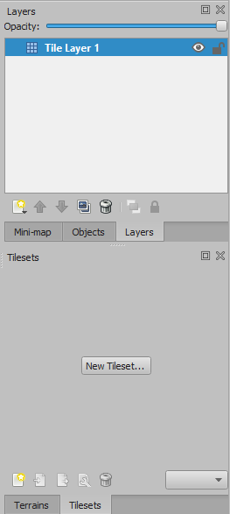

* Doing this allows you to choose which tiles you want to use on the particular layer. You might have tiles that are used for background use and others that are for use of player interaction/ walking or running on.
* Once you have created your game environment, you want to export this to a CSV or JSON format (File > Export As... > …) then change the necessary “Save as type” where appropriate.
* *Note: With game environments, it is not strictly on using CSV and JSON. You can mix it with native shape drawings (rectangles, circles, etc) and external images.*

# Task 3: Create a Level Environment

Now that you have experimented with using Piskel and Tiled, using the skills you have picked up from doing the past two tasks. Start creating a design for your upcoming Assessment 2 game or start working on getting ideas together for your level environment and overall design. Start to make necessary tile sets and sprite sheets to fit with your game that you will be developing. If you are working on your game as a team, it would be important to divide up the tasks and work on who will do what.

# Additional Tasks

In addition to the three tasks for this lab, start to get together how you are going to approach your game you wish to develop and do research on what you think it achievable using Phaser 3. If working within a team of 2, think about who will be involved in which section of the game.

# Important Information

***Keep backup copies of your projects!***

It is important to keep backup copies of your work when progressing over the weeks. I recommend you use OneDrive or Google Drive as a secondary cloud backup along with a USB. If you backup your work each week this will cause less problems when it comes to later weeks.